First screen of Student Debate Demo, displays the list of students

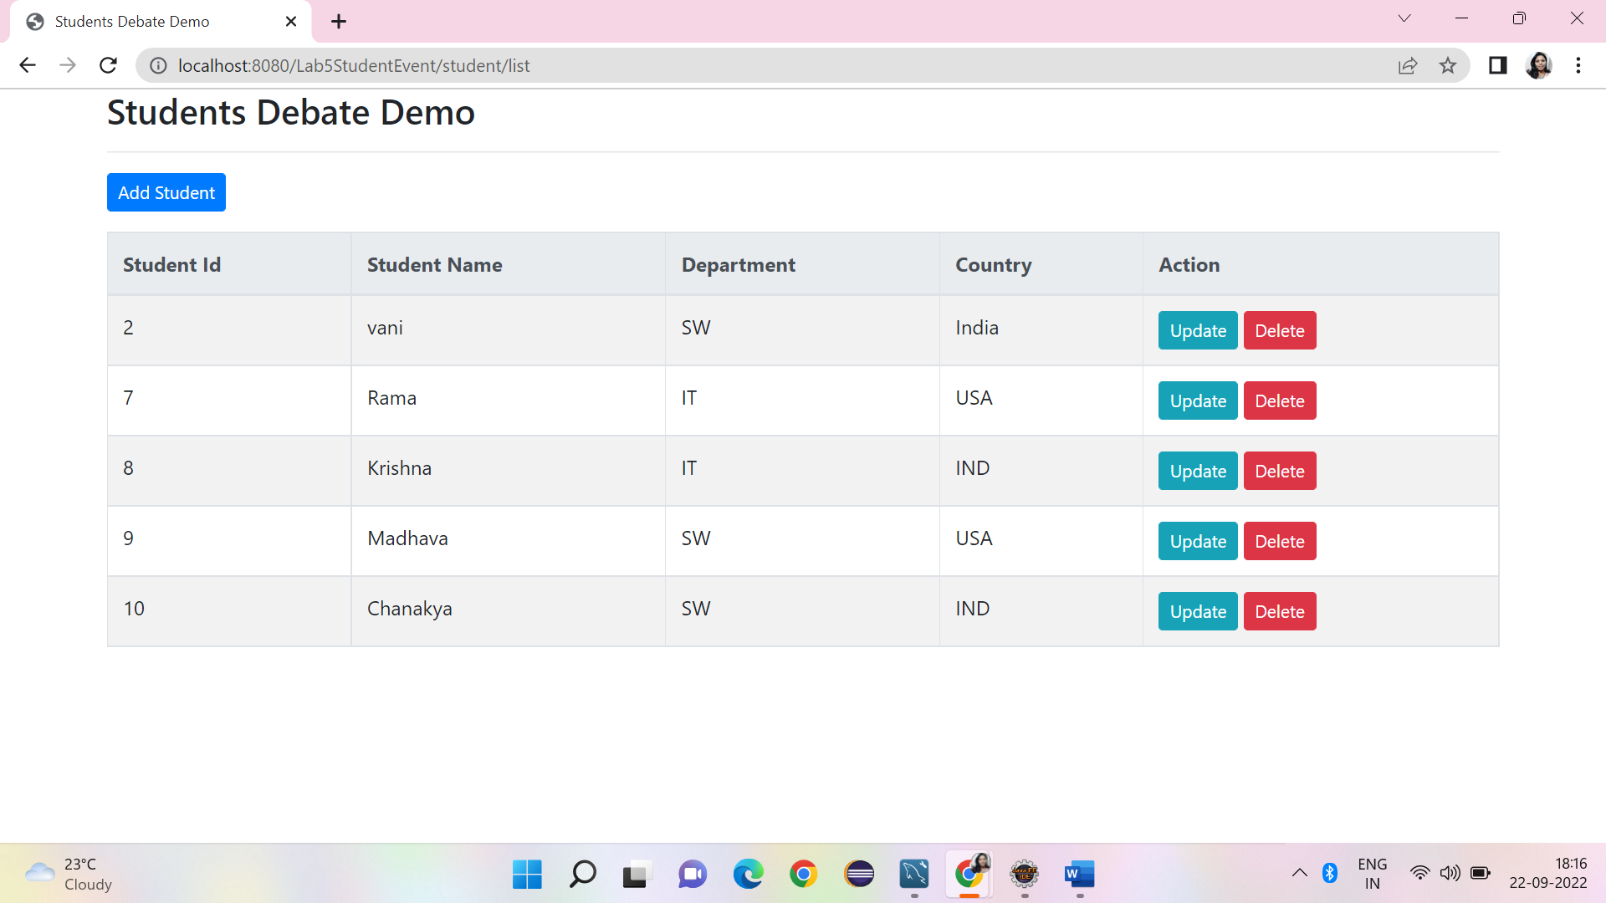

Add student screen

Student added to the database and same is displayed from main screen

Record inserted into database table

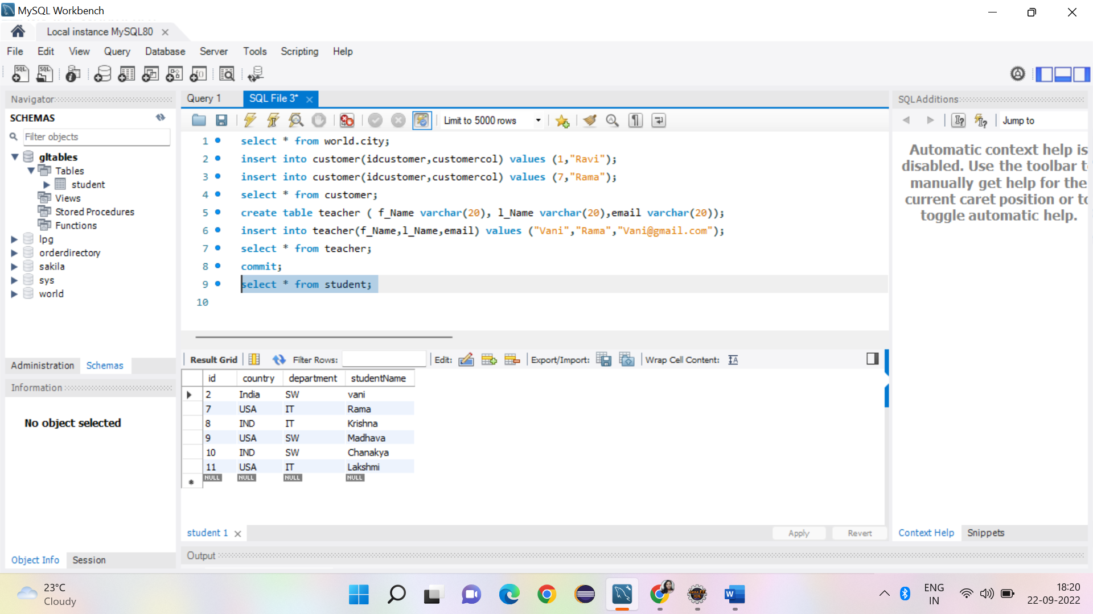

Update student, changing from India to IND for student ID =2

Delete student record ID 8

Student database image after CRUD operations performed

